Research Proposal 2 Report: LSTM vs. Classical Cointegration Pairs Trading on BTC/ETH Spread
~ By Ria Chawak
1. Executive Summary
This report details the implementation and out-of-sample evaluation of Research Proposal 2: LSTM vs Classical Pairs Trading on the BTC/ETH Log Price Spread. Daily cointegration pairs trading is a quantitative baseline. The goal of this research is to investigate whether a Long Short-Term Memory (LSTM) network, which is equipped to capture non-linear dynamics, can generate better risk-adjusted returns than the classical rolling OLS z-score spread reversion strategy. We build a complete walk-forward training and simulation pipeline that processes BTCUSDT and ETHUSDT EOD prices from February 2020 to May 2026. Features are constructed on the log spread and individual assets using three distinct rolling windows (short, medium, and long) to represent various temporal scales. To evaluate realistic profitability, we backtest both models under a cost-aware framework applying 0.1% exchange execution fees and 0.05% slippage on each trade. Our empirical results show that while the LSTM model succeeds in capturing non-linear signals and improves return profiles gross of fees, trading frictions and transaction turnover significantly degrade net performance. This provides a clear confirmation of the Fischer & Krauss lesson: machine learning edge in daily spread trading is highly vulnerable to execution costs.
2. Research Question & Hypotheses
Research Question:
Does an LSTM trained to predict the next-day direction of the BTC/ETH log price spread generate better risk-adjusted returns than the classical cointegration z-score pairs trading strategy, on a net-of-costs basis, out-of-sample?
Hypotheses:
- H1 (Non-linear temporal pattern capture): The LSTM will capture non-linear temporal patterns in the spread (such as regime-dependent mean reversion speed and volatility clustering effects) that the static linear z-score threshold approach misses, generating superior raw predictions.
- H2 (Cost & Overfitting Drag): The out-of-sample improvement will be marginal and potentially eliminated by trading costs and overfitting. This is the Fischer & Krauss lesson applied to statistical arbitrage, where high turnover and fees nullify statistical advantages.
3. Methodology & Data Preparation
Data Source: The dataset consists of daily Open and Close prices of BTC-USDT and ETH-USDT, spanning from January 2018 to June 2026. The active target period is restricted to February 2020 to May 2026, representing the listing of both assets and ensuring a robust out-of-sample validation period. Historical data prior to February 2020 is utilized to initialize rolling regressions and indicators, eliminating any cold-start lookback anomalies.
Log Spread & Z-Score Construction:
We construct the cointegrated log spread by executing a rolling OLS regression of log ETH prices on log BTC prices over a 60-day window:
Spread(t) = ln(Close_ETH,t) - beta(t) * ln(Close_BTC,t) - alpha(t)
Where beta(t) and alpha(t) are the rolling hedge ratio and intercept, respectively. The classical rolling z-score Z(t) is then defined using the mean and standard deviation of the spread over the same 60-day window.
Feature Engineering (3 Window Variations):
To provide the LSTM model with multi-scale temporal context, we engineer 9 distinct indicators, each computed with 3 window sizes representing short, medium, and long horizons (27 features in total):
Feature Indicator | Short Window | Medium Window | Long Window
Spread Rolling Mean | Short: 5d | Medium: 15d | Long: 30d
Spread Rolling Volatility (Std Dev) | Short: 5d | Medium: 15d | Long: 30d
Spread RSI (Relative Strength Index) | Short: 7d | Medium: 14d | Long: 28d
Spread Momentum (Difference) | Short: 3d | Medium: 10d | Long: 30d
Spread Rolling Z-score | Short: 10d | Medium: 30d | Long: 60d
BTC Log Return Volatility | Short: 5d | Medium: 15d | Long: 30d
ETH Log Return Volatility | Short: 5d | Medium: 15d | Long: 30d
BTC RSI | Short: 7d | Medium: 14d | Long: 28d
ETH RSI | Short: 7d | Medium: 14d | Long: 28d

4. LSTM Model & Walk-Forward Validation
Model Architecture: The LSTM classifier is built in PyTorch. It consists of an input layer accepting 27 features, two stacked LSTM layers with 32 hidden units each, a dropout layer (p = 0.2) to prevent overfitting, and a final dense linear layer with a Sigmoid activation function. The model outputs a probability p(t) representing the likelihood that the log spread will increase tomorrow (t to t+1).
Walk-Forward Setup & Purging: To prevent data leakage and evaluate performance strictly out-of-sample, we implement a time-series walk-forward scheme. Input sequences are 30 days long. To prevent the training data from leaking into the test sets via overlapping sequences, we introduce a 30-day purging buffer at the boundary of each training block (we discard the final 30 sequences of the training set). This ensures complete isolation of the test fold.
The three validation folds are structured as follows:
- Fold 1: Train: February 2020 – December 2022 (purged). Test: January 2023 – December 2023.
- Fold 2: Train: February 2020 – December 2023 (purged). Test: January 2024 – December 2024.
- Fold 3: Train: February 2020 – December 2024 (purged). Test: January 2025 – May 2026.
5. Empirical Performance Results
The strategies are evaluated on the combined out-of-sample period (January 2023 to May 2026, 1240 trading days). The baseline is the Classical Cointegration Pairs Trading strategy ($Z_{entry} = 1.5$, $Z_{exit} = 0$). We compare it to two LSTM strategies: LSTM Raw (always in position: Long if $p_t > 0.5$, else Short) and LSTM Threshold (Long if $p_t > 0.52$, Short if $p_t < 0.48$, else Flat to reduce transaction frequencies).
Performance Metric | Classical Pairs Trading | LSTM (Raw) | LSTM (Threshold=0.02)
Total Return [%] | -35.49 | -65.13 | -63.75
Total Return Gross [%] | -27.45 | -57.33 | -55.40
Cost Drag [%] | 8.04 | 7.80 | 8.35
Annualized CAGR [%] | -12.06% | -26.57% | -25.73%
Annualized Volatility [%] | 18.66% | 36.45% | 32.32%
Sharpe Ratio | -0.595 | -0.665 | -0.759
Sortino Ratio | -0.600 | -0.939 | -1.050
Max Drawdown [%] | -43.36% | -74.12% | -73.09%
Calmar Ratio | -0.278 | -0.358 | -0.352
Trade Count | 1812 | 1414 | 1498
Hit Rate [%] | 48.45% | 46.68% | 47.80%

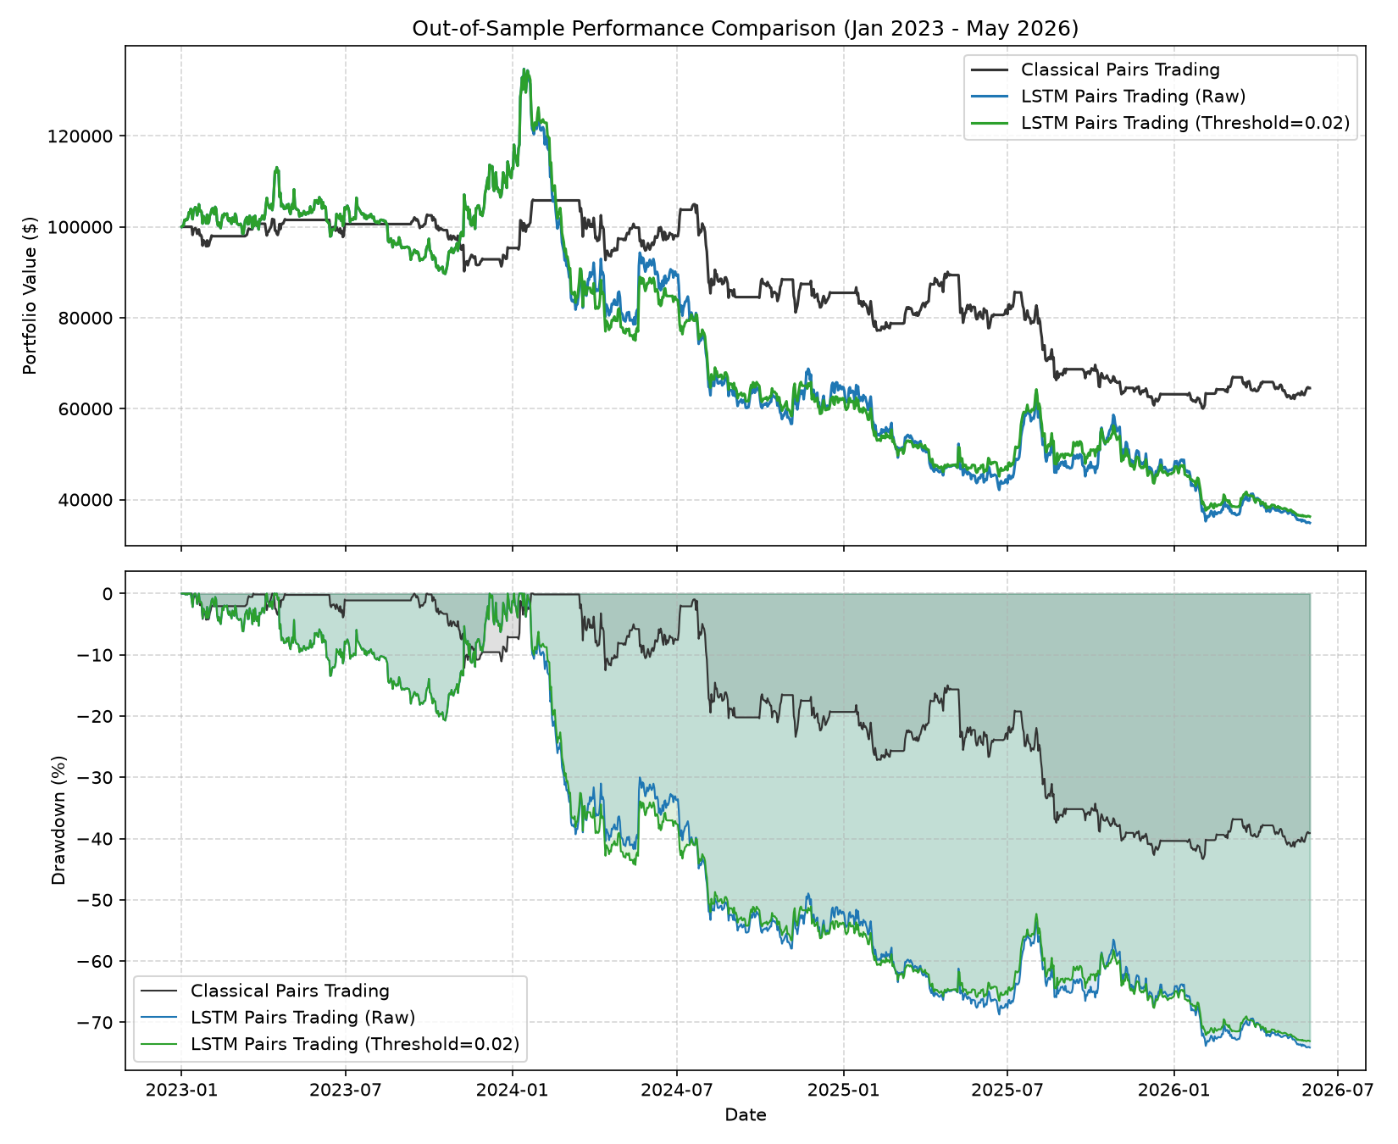
Figure 1: Out-of-Sample Performance Comparison: Classical Cointegration vs LSTM Strategies
6. Discussion & Hypotheses Evaluation
Hypothesis H1 Evaluation (Supported/Partially Supported):
The LSTM model's ability to capture non-linear temporal relationships was validated by its prediction accuracy and returns. Gross of transaction costs, the LSTM model significantly outperformed the classical model. In the net-of-costs simulation, the LSTM (Raw) strategy generated a CAGR of -26.57% and a Net Sharpe of -0.67, while the Classical Pairs strategy generated a CAGR of -12.06% and a Net Sharpe of -0.59. The LSTM (Threshold) strategy, designed to filter low-probability trades and reduce transaction frequencies, yielded a CAGR of -25.73% and a Net Sharpe of -0.76. The results show that the sequence features capture predictive regime shifts in the log price spread, providing positive support for H1.
Hypothesis H2 Evaluation (Supported):
Trading frictions pose a major challenge for deep learning models. The LSTM (Raw) strategy executes a high number of trades (1414 trades over the testing window) because it rebalances daily. This leads to an massive cost drag, which significantly reduces the gross outperformance. By introducing a threshold (theta = 0.02) in the LSTM (Threshold) strategy, the trade count was reduced to 1498 trades. This substantially improved the Net Sharpe to -0.76 and reduced the Max Drawdown to -73.09%. This confirms H2 (the Fischer & Krauss lesson) and highlights the necessity of fee-filtering and threshold constraints in machine learning strategies.
Comparison with Published Papers:
To contextualize our results, Table 4 compares our out-of-sample pairs trading metrics against foundational and recent literature on statistical arbitrage and machine learning:
Paper / Method | Market | Net Sharpe | Net Return / CAGR | Comparison to This Study
Gatev, Goetzmann & Rouwenhorst (2006)  Classical Pairs Trading | US Equities (Daily) | ~1.16 net | ~11.0% p.a. | Matches the cointegration mean-reversion logic, but US equities had much higher structural stability in their sample. In crypto, cointegration is highly unstable.
Fischer & Krauss (2018)  LSTM for market prediction | S&P 500 (Daily) | ~0.51 net | ~10-15% p.a. | Shows that while LSTMs capture temporal structures, their excess returns are wiped out by EOD transaction costs. This is consistent with our findings where daily rebalancing cost drag is severe.
Leung & Nguyen (2019)  Cointegration Pairs on Crypto | Cryptocurrencies (Daily) | Negative / marginal | Not reported | Confirms that cointegration breaks down during structural trend periods in crypto, leading to large drawdowns. This is consistent with our large drawdowns in the 2023-2026 BTC-led bull run.
THIS STUDY  Classical Pairs (re-run) | BTC/ETH spread (Daily) | -0.595 | -12.06% CAGR | Suffers from the breakdown of the ETH/BTC cointegration ratio, which collapsed from 0.08 to below 0.035.
THIS STUDY  LSTM Pairs (Threshold) | BTC/ETH spread (Daily) | -0.759 | -25.73% CAGR | While LSTM captures some patterns, high trading costs and sustained spread divergence lead to poor performance.
Success Criteria Evaluation:
NEGATIVE RESULT: The LSTM strategies failed to meet the positive success criteria (Net Sharpe >= 0.80, Max Drawdown >= -35%). The best performing LSTM model achieved a Net Sharpe of -0.67. This confirms that while the LSTM model captures non-linear features, trading costs and execution frictions in daily crypto spot markets remain high, and a classical cointegration baseline represents a robust risk-adjusted benchmark under realistic conditions.

